Document 1 – A timeline of South African history

1651: Dutch settlers arrive in South Africa. In 1756, they import slaves from West Africa, Malaysia, and India, establishing the dominance of whites over non-whites in the region.

1867: Diamond mining begins in South Africa. Africans are given the most dangerous jobs, are paid far less than white workers, and are housed in fenced, patrolled barracks. Oppressive conditions and constant surveillance keep Africans from organizing for better wages and working conditions.

1910: The Union of South Africa is formed. English and Dutch are made official languages. The all-white government decides that blacks can vote but cannot hold office.

1912: The African National Congress is formed. This political party aims to organize Africans in the struggle for civil rights.

1913: The Native Lands Act gives 7.3% of the country's land to Africans, who make up 80% of the population. Africans are prohibited from owning land outside their region. Africans are allowed to be on white land only if they are working for whites.

1946: African mine workers are paid twelve times less than their white counterparts and are forced to do the most dangerous jobs. Over 75,000 Africans go on strike in support of higher wages. Police use violence to force the unarmed workers back to their jobs. Over 1000 workers are injured or killed.

1948: The Afrikaner National Party wins elections on a platform of strict racial segregation. Apartheid becomes the law of the land.

- What are two ways that Africans were discriminated against by the white government?

- What happened when Africans tried to protest poor working conditions?

Document 2– Statistical Comparison (1978)

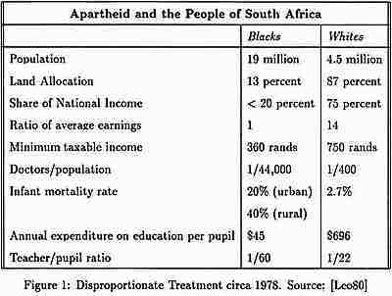

- According to the table, what are three ways that whites had better living conditions than blacks in South Africa in 1978?

Document 3 – The Apartheid Laws of South Africa

Prohibition of Mixed Marriages Act, of 1949
Prohibited (made illegal) marriages between white people and people of other races.

Immorality Amendment Act, of 1950
Prohibited adultery, attempted adultery or related immoral acts (extra-marital sex) between white and black people

Group Areas Act, of 1950
Forced physical separation between races by creating different townships (neighborhoods) for different races

Pass Laws, of 1952
Forced black people to carry identification with them at all times. It was a criminal offence to be unable to produce a pass when required to do so by police. No black person could leave his/her township unless going to work, and must show pass upon entering the white township.

Reservation of Separate Amenities Act, of 1953
Forced segregation of all public building and public transportation with the goal of ending contact between whites and other races. “White Only” and “Non-Whites Only” signs were put up.

Terrorism Act, of 1967
Any person who uses violence to protest against the government of South Africa may be put in jail without trial. White men who encourage Africans to disobey the apartheid laws may be fined, jailed, or both.

- In what ways did the apartheid laws help whites maintain control over non-whites?

- Which law do you think was the most unjust? Why?

Document 4 – The Sharpville Massacre

The Sharpeville Massacre on the 21st March 1960. Police opened fire on protesters, resulting in 69 people being killed and 180 wounded. Of the 143 admitted to hospitals; there were 110 men, 29 women and 4 children. The bodies of those who died were brought by truck to a mass funeral.
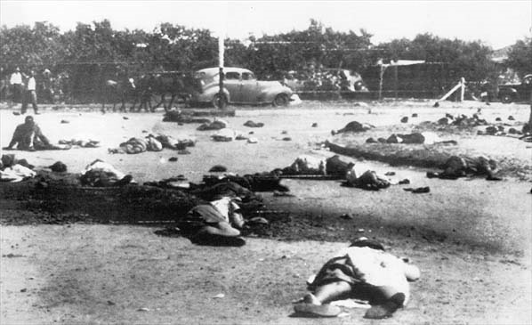

- What caused the massacre in Sharpville?

- How do you think the Africans responded?

Document 5 - Nelson Mandela’s “I am Prepared to Die” Speech (1964)

Africans want to be paid a living wage. Africans want to perform work which they are capable of doing, and not work which the Government declares them to be capable of. Africans want to be allowed to live where they obtain work, and not be removed from an area because they were not born there. Africans want to be allowed to own land in places where they work, and not to be obliged to live in rented houses which they can never call their own. Africans want to be part of the general population, and not confined to living in their own ghettoes. African men want to have their wives and children to live with them where they work, and not be forced into an unnatural existence in men's hostels. African women want to be with their menfolk and not be left permanently widowed in the Reserves. Africans want to be allowed out after eleven o'clock at night and not to be confined to their rooms like little children. Africans want to be allowed to travel in their own country and to seek work where they want to and not where the Labor Bureau tells them to. Africans want a just share in the whole of South Africa; they want security and a stake in society. . .
During my lifetime I have dedicated myself to this struggle of the African people. I have fought against white domination, and I have fought against black domination. I have cherished the ideal of a democratic and free society in which all persons live together in harmony and with equal opportunities. It is an ideal which I hope to live for and to achieve. But if needs be, it is an ideal for which I am prepared to die.

- According to Mandela, what do Africans want? (List 3 specific changes)

- What is Mandela’s ultimate dream, described in his final statement? What is he willing to do to achieve his dream?

Document 6 – Timeline of Nelson Mandela’s Political Activism

1943 – Joins the African National Congress (ANC) as a 25-year old
1944—Forms the ANC Youth League
1952—Opens first black law firm in South Africa
1956—Is accused (with 150 others) of “conspiring to overthrow the government” by violent means but is acquitted (found not guilty)
1960 –After Sharpville Massacre, goes into hiding and forms underground military group with armed resistance.
1964 – Captured and convicted of sabotage and treason. Sentenced to life-in-prison. Originally placed in Robben Island prison, where he would remain for 18 years
1980—An international “Free Nelson Mandela” campaign is launched

- For what reason was Mandela placed in jail?

- How did Mandela’s tactics differ from Gandhi’s?

Document 7 – Political Cartoon about Nelson Mandela
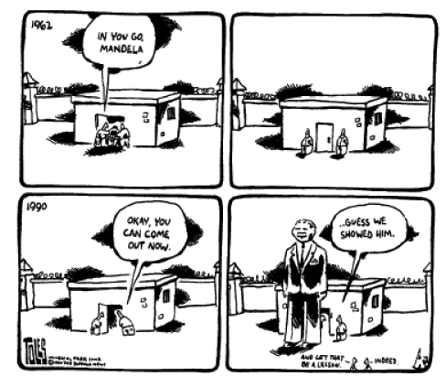
- What is the attitude of the artist in the cartoon?

- What impact did Mandela’s imprisonment & later release have on the ending Apartheid movement?

Document 8 – Success of the Anti-Apartheid Movement

Desmond Tutu was a black Anglican bishop and civil rights leader. Tutu and other activists convinced foreign nations and businesses to limit trade and investment in segregated South Africa. Over time, these nonviolent means of protest had a strong effect.

F.W. de Klerk, a white South African, became president of South Africa in 1989. He realized that the time for reform was long past. De Klerk legalized the ANC and released Mandela in 1990. He also abandoned apartheid and repealed segregation laws.

In 1994, an election was held in which South Africans of all races could vote. The people elected Mandela for their new president.

- How did Desmond Tutu help put pressure on the Apartheid government of South Africa to change?

- What role did F.W. de Klerk have in ending apartheid?

Document 9 – Image of the first South African elections (1994)

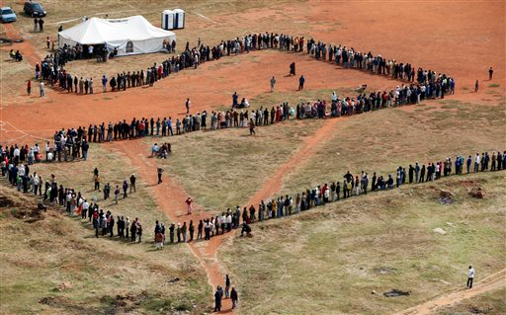

- What are the people standing in line to do? Why is this significant?

